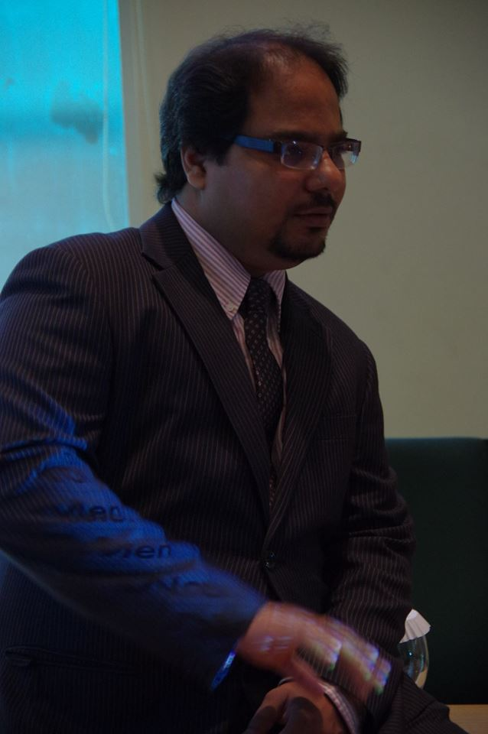
Raheel Rupani
CEO | Data Consultant | International Trainer
Microsoft Certified Office Specialist of Excel 2010
Certified for Analyzing and Visualizing using Power BI and Excel
IBM Certified for Cognos Report Author
Certified Data Analyst Using R and Python
Certified Blockchain Business Foundation
Scholarship Holder for Udacity Bertelsmann Data Track

Meet Raheel, an esteemed senior-level Information Technology trainer and Consultant with an illustrious career spanning over two decades. Renowned for his expertise in data analytics, Raheel holds the prestigious "Brainbench" certification for MS Excel 2010 Expert level and MS Project Expert level. His journey into the world of technology extends into the realms of Data Science, Big Data, and advanced programming languages like Python and R. With a keen eye for detail and a passion for uncovering insights, Raheel has led numerous impactful Data Analytics projects for both local and international clients.
Raheel's proficiency extends beyond conventional boundaries; he is a trailblazer in the fields of Robotic Process Automation (RPA) and Automation, optimizing workflows and processes for enhanced efficiency. His innovative solutions harness the power of RPA, transforming complex tasks into streamlined, automated processes.
Furthermore, Raheel is a visionary in the realm of Machine Learning, where he leverages sophisticated algorithms and predictive modeling to revolutionize data-driven decision-making. His expertise in Python allows him to delve deep into data, utilizing cutting-edge Machine Learning techniques to solve complex business challenges.
As the Chief Executive Officer at DMatrix Solutions, Raheel leads transformative projects in Power BI, Big Data, and Data Analytics across the USA and Africa. His strategic acumen is not limited to technical domains; Raheel excels in advising businesses on Marketing Tactics and Strategies, infusing data-driven insights to drive sales growth and ensure survival even in the most challenging market landscapes.
In the face of the Covid-19 pandemic, Raheel exhibited remarkable resilience and empathy. He conducted numerous online training workshops, covering a diverse array of topics, including Linux, Blockchain, Cyber Security, and Advanced Excel, with an emphasis on practical Data Analytics using Python. Raheel's commitment to education, coupled with his expertise in emerging technologies, has empowered professionals globally, enabling them to thrive in an ever-evolving digital landscape.
Raheel's multifaceted skill set, encompassing Data Analytics using Python, RPA, Automation, and Machine Learning, combined with his strategic insights, continues to drive innovation and transformation. His dedication to leveraging technology for business excellence makes him a true trailblazer in the dynamic intersection of IT and Data Analytics.
One of Raheel's key mantras is rooted in his famous quote: "If you are working on DATA, just talk with DATA; DATA will tell you what secret it is hiding inside." This philosophy underlines his deep understanding of the intricacies of data analysis.
Raheel has given training at various local and international organizations encompassing various industries, such as: Banking and Finance, Manufacturing, IT and Education with 95% positive remarks.
He has worked for many companies for development and Training work which include national and international companies (Turkey, Saudi Arabia, Kenya, South Africa, USA, Australia, Dubai, Canada, New Zealand)

For training assignments Raheel has directly worked with

State Bank of Pakistan,
MCB Bank,
Strategic System International,
Pakstan Refinery Limited,
Aga Khan Health Service (AGHS,P),
Aga Khan Planning & Building Service (AKPBS,P),
Aga Khan Ruler Service Pakistan (ALRS,P),
Buyer,
Packages Group
Ampak Soft International,
Crescent Bahuman Limited,
K-Electric,
Pearl Confectionary,
Institute of Bankers Pakistan (IBP),
Habib University Foundation,
Pepsicola International,
SCSPEB,
BBraun,
HBL,
TPS Pakistan (Pvt.) Ltd.
Tetrapak (World Wide),
Silk bank,
Smollan,
Descon Engineering (UAE),
Amcap Mortgage (USA)
Supreme Lending Mortgage (USA)
Maviro (Canada)
JaredJamesCRM (USA)
And many more.

For Public Program
People from Agha Khan Rural Support Program,
ICAP Members from ICAP
A.F. Ferguson & Co.,
Adamjee Insurance Limited,
Ali Akber Group,
Alkaram Textile Mills (Pvt.) Ltd.
Allied Bank Limited,
Arena Multimedia,
Bbraun Pakistan,
Descon Engineering Limited,
Engro Foods,
Etilize,
European Union Delegation to Pakistan,
Faisal Bilwany Associates,
Fauji Oil Terminal & Distribution Co.,
Habib Bank Limited,
HSBC,
ICI Pakistan,
Institute of Bankers Pakistan,
International Committee of Red Cross,
InterwoodMobel (Pvt.) Ltd.,
Karachi Stock Exchange,
Karachi University,
KASB Bank,
K-Electric ,
Khushhali Bank,
Lafarge Cement,
Lalpir Power,
Landscape Architecture Studio,
MCB Bank,
Medics Laboratories,
MISHMASH Group,
Multi Net,
Oasis Insights,
Pak Libya Holding Co,
Pakistan Military Accounts Department (PMAD),
Pfizer Pakistan,
PPS Pakistan (Pvt.) Ltd.,
Projection Consultant Plus,
Raaziq Group,
Sante Pharmaceuticals,
SIEMENS Pakistan,
Silk bank Limited,
Standard Chartered Bank,
UBL,
Valet Solutions and many more have participated in his public Workshops.

Testimonials Comments

I had the privilege of working with Raheel for 2 Days during Power BI Session. The experience was transformative and exceeded all my expectations. Raheel is an exceptional trainer with profound expertise in Data Analytics. Their ability to break down complex concepts into manageable, understandable segments is unparalleled. Each session was not only educational but also engaging and interactive, fostering an environment where learning felt both natural and enjoyable.
One of the standout qualities of Raheel is their dedication to their trainees. They provided personalized feedback, tailored advice, and were always available for extra support outside of scheduled sessions. This level of commitment demonstrated their genuine passion for helping others succeed.
Moreover, Raheel's enthusiasm and positivity are infectious. They create a motivating atmosphere that encourages everyone to push their limits and achieve their best. Their innovative teaching methods, combined with real-world applications, ensured that the knowledge gained was practical and could be immediately implemented.
Thanks to Raheel, I have seen significant improvement in my Power BI. I feel more confident and equipped to tackle challenges in my professional and personal life. I highly recommend Raheel to anyone seeking to advance their skills and knowledge in BI Tools.
Tayab – Airlink

Mr. Rupani conducted a comprehensive training on advanced Excel, which was tailored made. It was well planned and focused. WELDONE.
Mukham Wali – HR Head – Aga Khan Planning & Building Services, Pakistan

It’s nice to have a knowledgeable trainer. We learnt a lot and wish to practice it more often to have some expertise. We wish you good luck and highly recommended Mr. Raheel Rupani for such sessions on regular basis.
Irfan Siddique – Assistant President – Treasury – Muslim Commercial Bank

Course design and structure was very good. Session was very informative & contains lot of knowledge. Way of communication & teaching is Excellent.
M. Bilal Karim – Regional Manager – Sales – B.Braun Pakistan

The aim of the training was facilitate basic level & to some extent advance excel learning, I think the facilitator was successful and done remarkable well transferring knowledge.
Tariq Ahmed – Manager – Monitoring & Evaluation – Agha Khan Rural Support Program
The instructor's approach was not only informative but also engaging, making complex topics seem simple. The hands-on exercises and real-world examples provided a solid foundation for using Power BI effectively.
Boris Tatyana – ECA OFPM process coach Tetrapak Ukraine

Wow, what an eye-opening experience! The Power BI training I attended exceeded my expectations in every way. The trainer's deep knowledge & expertise were evident as they effortlessly
navigated through various features & functionalities of Power BI
Keshtova Kseniya – Logistic Analyst Moscow

Courses List
- Microsoft Excel for Basic to Advance
- Microsoft Excel Dashboards
- Microsoft Excel Master Class
- Advance Dashboard Reporting using Excel
- Excel Machine Learning
- Business Application using Power Apps (No Code, Less Code)
- RPA using Power Automate
- RPA using UiPath
- Analyzing and Visualizing Power BI
- Mastering Excel Power Pivot and Power Query
- Mastering Power BI DAX Formulas
- Microsoft Project
- Microsoft Office Suit (Word, Excel, Power Point, Outlook)
- Microsoft Access
- Microsoft SQL Server Querying and Optimization
- Data Analysis using Python
- Pythonic Excel – Python for Excel Users
- Pythonic Dashboard
- Data Analysis using R Language
- Excel Automation using Macros / VBA
- Microsoft Excel for Sales Professional
- Microsoft Excel for Finance Professional
- Microsoft Excel for HR Professional
- Advance Presentation / Infographics Skills using Power Point
- Blockchain Beyond the Basics
And much more….

Contact :
Raheel Rupani
DMatrix Solutions
Cell / Whatsapp : +92 315 8988 911
Email: raheel@dmatrixsolutions.com
Linkedin: www.linkedin.com/in/raheelrupani

